# Question Types

A question can have 1, 2, 3, 4+ answers.

1 answer can be implemented using “Text Box” or “Slide Bar”.

Ex:

**Q**: How long does corona last?

2

**Answer**: Years. (Text Box)

**Answer**: 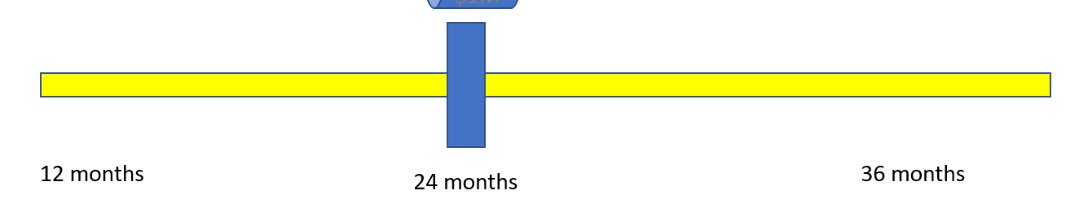 (Slide Bar)

2, 4+ answers can be implemented using “Radio Button”s.

Ex:

**Q:** Who are you?

**Answer1**: Scientist (Radio Buttons)

**Answer2**: Programmer

**Answer3**: Designer

**Answer4**: Worker

**Answer5**: Other

**………**

3 answers can be implemented using “Triangle Tool” or “Radio Buttons”.

**Q**: Who are you?

**Answer1**: Scientist (Radio Buttons)

**Answer2**: Programmer

**Answer3**: Designer

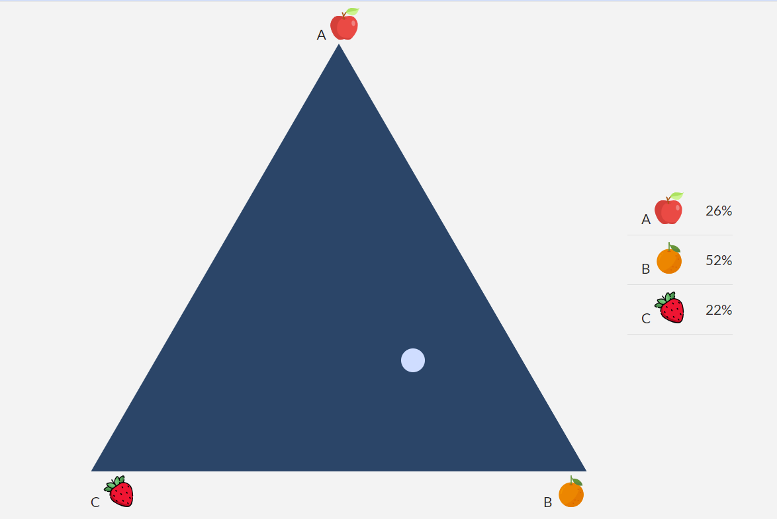 (Triangle Tool)

# Question Hierarchy

A question hierarchy have hierarchy name and a list of questions as hierarchy tree.

Ex:

Corona – A list of typical questions, which have only 1 answer.

How long would it be last? - 1 answer as text box

How much would it be cost to develop the medicine? – 1 answer as slide bar.

…..

Cancer .

Is there any treatment way for cancer? - 2 answers as radio button.

How many peoples are in cancer? – 1 answer as slider or roller (UI for list of many)~~text box or radio button~~

What do you prefer in below 3 options? – 3 answers as triangle tool.

…..

# Customer Action

~~Customers~~ Website admin will ~~choose the interesting~~ created the necessary question hierarchy for the questionnaire. No customer action is required here, in the sense that they simply answer questions. The website will navigate them through the survey.

The person answering Questionnaire / Survey will be guided through the list (of questions in a personalized survey, which will ask them different questions from the Survey hierarchy / branching) and will answer.

They can see the statistic results for the questions only after they answered (this will be helpful to let them answer our questions so that we can get more answers).

# Admin Action

Admin add questions ~~and remove bad answers~~.

Admin add question hierarchy and see statistical results.

~~If a bad customer report invalid answers.~~

~~For example, if a customer answer like “Corona will last for 100000000000 years”, then this answer must be removed.~~

There are no invalid answers, because everything has a range.

For example, the list of options for how long Coronavirus will last, can go out to 20-30 years, at most. This is practically meaning “forever”, a generation-long span of time. So, there’s no need to go beyond that. This could be on a slider, or a roller. Both could work with mobile platform.

I like the slider. There could be a range of discrete options, for example rather than having 20 options for every year 1-20, there could be a few bins. I think that’s preferable to a more “continuous” function with all integers. So, there could be 8 options: 3 months, 6 months, 1 year, 2, 3, 5-10, 10-20, 20+ years.